AI Workforce Odyssey: Workforce Transitions Under AI Pressure

Model Overview
The model represents 28 workers in a labor market where AI pressure falls more heavily on routine work. Each tick is one month, and the same model structure is used to compare a Tech-Driven scenario with a Human-Centric scenario.

Worker Design
Workers differ by task type, routine share, and adaptability. They move across five states: employed, at-risk, in-training, unemployed, and re-employed. Displaced workers receive transfers rather than fictitious labor income, and retraining builds human capital by raising adaptability.

Emergent Mechanism
The main emergent mechanism is the interaction of a limited training system with local coworker spillovers on the workplace grid. Training capacity is explicitly capped, but clustering and uneven recovery are not programmed as outcomes; they arise because adjacent coworkers affect one another’s training and recovery chances.

Scenario Results
This package uses the most recent complete NetLogo export for each scenario because the exact benchmark pair was not present.
In the current audited comparison, Tech-Driven reaches a peak unemployment rate of 25.0% while Human-Centric peaks at 7.1%, a gap of 17.9 percentage points. Human-Centric also ends with 0.65 more average liquid assets per worker and a lower burden Gini among exposed workers by 0.345.
Metric | Tech-Driven | Human-Centric
Peak unemployment | 25.0% | 7.1%
Share ever unemployed | 46.4% | 10.7%
Average unemployment time among exposed | 49.4 months | 17.0 months
Burden Gini among exposed | 0.542 | 0.196
Average liquid assets | 3.07 | 3.72
Average supportive coworkers | 1.61 | 1.39
Recovery cluster share | 72.7% | 33.3%

These results fit the model logic. Under Tech-Driven, tighter support creates a stronger training bottleneck and larger unemployment burden. Under Human-Centric, workers spend less time unemployed, retain stronger balance sheets, and face a much smaller aggregate disruption path.

The mechanism linking these gaps is queue pressure plus local spillovers. In Tech-Driven, scarce training seats and longer courses leave more workers waiting in at-risk or unemployed states, so fewer supportive examples are visible on the grid (1.61 supportive coworkers on average versus 1.39 in Human-Centric). That weaker local encouragement slows movement out of disruption and leaves many of the workers still in recovery states clustered together by tick 200 (72.7% versus 33.3%), which is why the unemployment burden remains much higher in the Tech-Driven case.

The clustering metrics should be read carefully. A low final recovery-cluster share does not necessarily mean weak coworker spillovers; it can also mean that fewer workers remain in in-training or re-employed states by the final tick. That is why the memo reads recovery-cluster share alongside average supportive coworkers and the workplace-grid screenshots.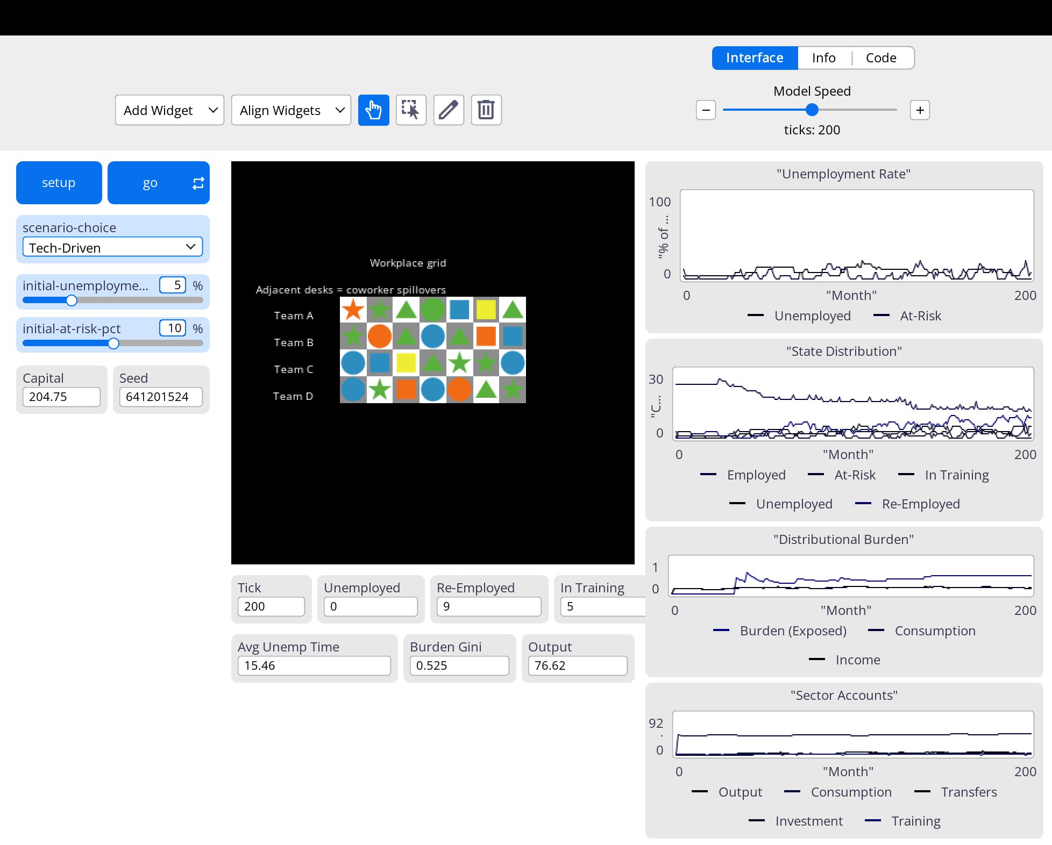
Figure 1. Tech-Driven scenario at tick 200: workplace grid and system plots
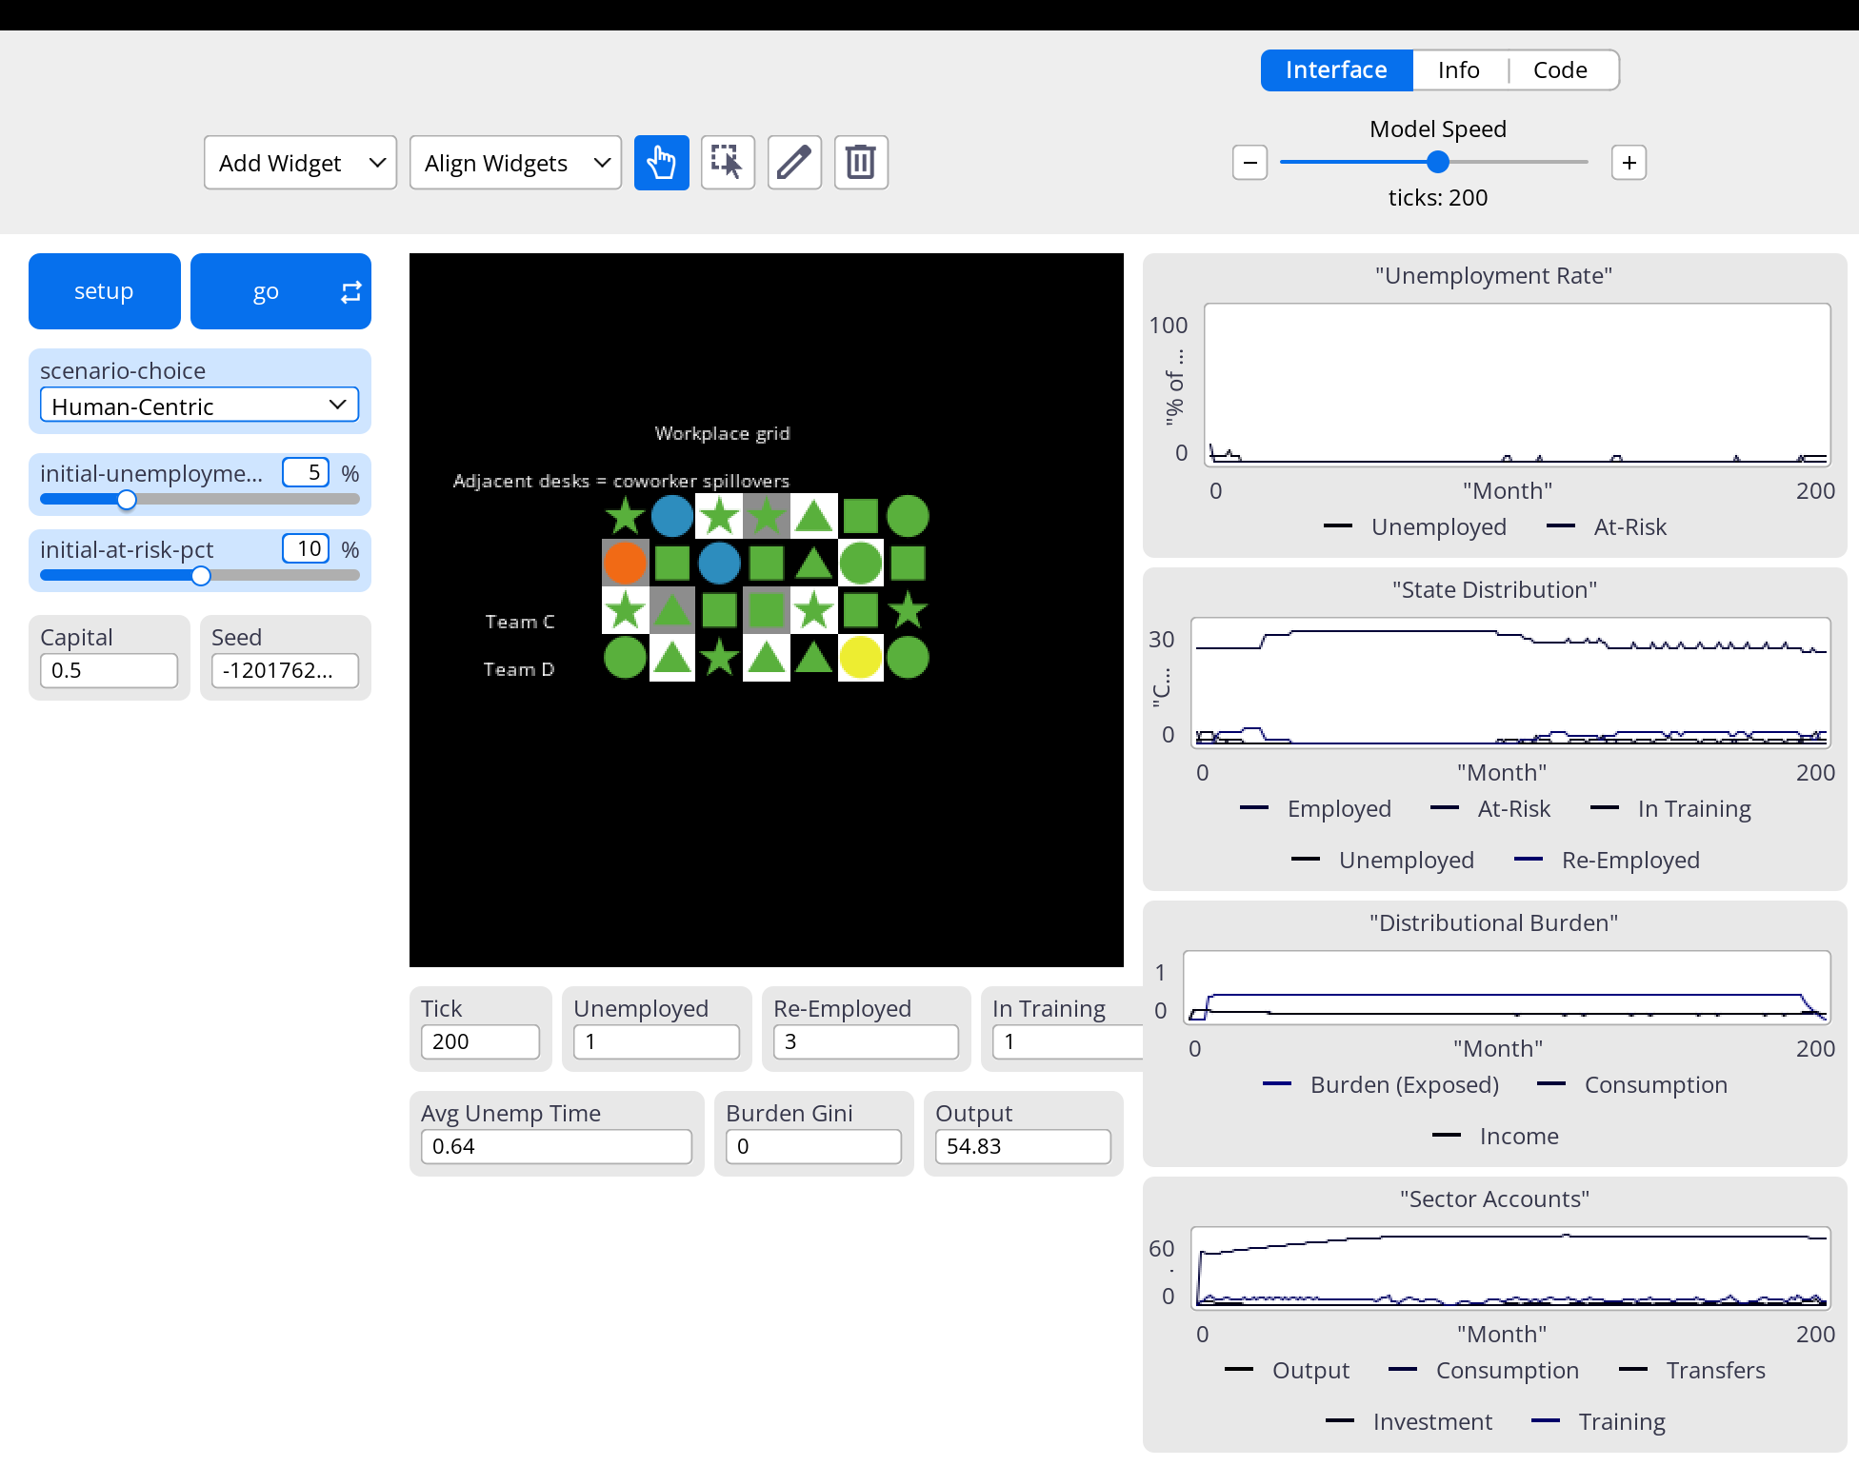
Figure 2. Human-Centric scenario at tick 200: workplace grid and system plots

Reflection
What is explicitly programmed: displacement thresholds, training admission, timed transitions, transfer support, and household-budget accounting. What emerges: queue pressure, unequal recovery, and local recovery clusters generated by coworker spillovers on the workplace grid.
A key limitation is that firms and government are not separate agents. The model is therefore best interpreted as a stylized labor-transition simulation rather than a full macroeconomic equilibrium model.

